Detailed Game Specification:  
Brick Breaker

Course: COMP 2659, Winter 2015  
Instructor: Paul Pospisil  
  
Authors: Braedan Orton & Cumar Yusuf  
Last Modified: Jan 29th, 2015

# 1. General Game Overview

Brick Breaker is a game which revolves around the user controlling a paddle that bounces a ball around in an attempt to destroy layers of bricks on the screen to earn a high score. Each brick is worth 10 points. The paddle is located on the bottom of the screen, and can move left or right at a fixed speed. Bricks are aligned in rows along the top with gaps between them, having different combinations depending on level, and must be broken by being hit by the ball. As the number of consecutive bounces increases, the ball speed will increase. This game is life based, and will result in a game over if all lives are lost. Time permitting, a high score is recorded in a leaderboard, along with initials, showing the best five high scores.

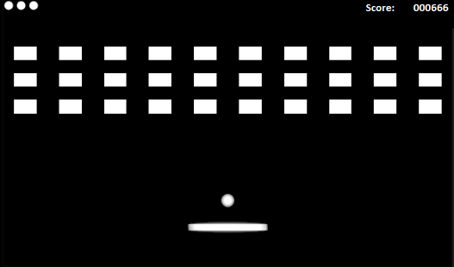

Source: https://lh5.ggpht.com/Nb89RFGYgRJ1mk2jztdVzZ0LRq6hs_1_Itvn_rWDDdiizJgC2KvmAfWmxzz7PSQWi64=h310

# 2. Game Play Details for Core 1-Player Version

## Objectives and Rules

The game will begin with a full set of bricks. The player will start with three lives and a score count of zero. Each time the player clears all bricks from the screen, a new full set of bricks will be added. The player will continue to play until all lives are lost.

The objective of the game is to prevent the ball from touching the bottom of the screen. If it does, the player has lost a life. If the player is out of lives, then the player has lost the game and the score will be tallied up. The game keeps a score count of how many bricks a player breaks. Each brick smashed is worth 10 points. If a player loses a life, score is decreased by 100 points, without decreasing below zero. The speed of the ball will increase every time the ball bounces ten consecutive times without touching the bottom, to a maximum of five times the original speed.

## Objects

|  |  |  |  |
| --- | --- | --- | --- |
| Object | Properties | Behaviours | Graphical Image |
| Ball | - position  - variable speed  - vertical and horizontal speed  - size  - bounce counter | - moves around the screen on a predetermined slope. |  |
| Scoreboard | -position  -size | - tally up the score |  |
| Brick | - position  - has it been smashed yet  - size | - smash if touched by ball |  |
| Paddle | - position  - constant speed  - size | - move right or left |  |
| Life counter | -position  -size | -keeps track of current life total |  |
| Screen | -dimension | - displays all other objects |  |

## Physics

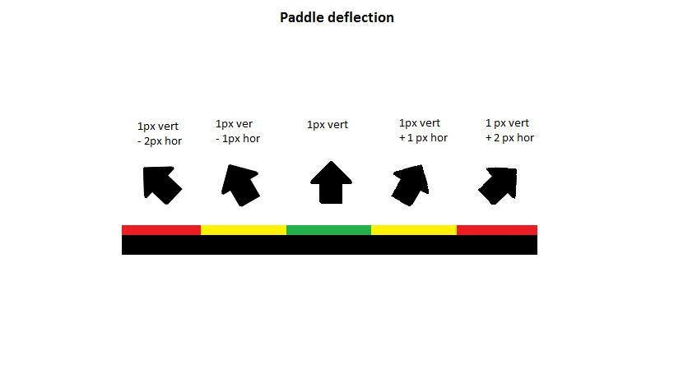When the ball touches the surface of the paddle, it will touch it on one of five sections. Each section will cause the ball to deflect at a different angle. The centre will cause it to deflect straight up, the sections immediately adjacent to the centre will cause the ball to deflect at a slope of x+y, and the furthest from the centre will cause the ball to deflect at a slope of 2x+y. The x of all sections to the left of centre will be negative, and the sections to the right will be positive.

When the ball collides with a brick it will smash that brick and the ball will deflect back at its current slope with the y value inverted if the top or bottom is struck, and the x value if a side is struck. The bricks will be far enough apart so that the ball will not be able to collide with two at once.

When the ball collides with the side walls, it will deflect at the same slope, with the x value inverted. If the top wall is struck, the y value will be inverted instead, sending the ball downwards.

## Asynchronous (Input) Events

|  |  |  |
| --- | --- | --- |
| Event Name | Triggering Input Event | Description |
| Move paddle | - right arrow key to move the paddle to the right  - left arrow key to move the paddle to the left  - holding either key will cause continual movement until the key is released | - The arrow keys will allow the user to change the paddle’s location left or right |
| Launch ball | -space bar to launch ball from paddle | - The ball will begin each level, and restart after a life is lost, attached to the centre of the paddle, waiting for the user to begin. |

## Synchronous (Timed) Events

|  |  |  |
| --- | --- | --- |
| Event Name | Trigger Timing | Description |
| -Ball moves | -Varying speeds, depending on level conditions | -The ball will move in the correct direction at a speed relative to the number of concurrent bounces. |
| -Paddle moves | -every 2/70ths of a second | -The paddle location will be updated to on the screen |

## Condition-Based (Cascaded) Events

|  |  |  |
| --- | --- | --- |
| Event Name | Triggering Condition | Description |
| -Ball hits block | -Ball moves | -When the ball collides with a block, the block will be destroyed, and the ball will bounce off at an angle mirroring the angle it struck with. |
| -Ball hits wall | -Ball moves | -When the ball collides with a wall, the ball will bounce off at an angle mirroring the angle is struck with. The speed of the ball may increase depending on the number of paddle + brick collisions without a life lost. |
| -Ball hits paddle | -Ball moves | -When the ball moves it may collide with the paddle, and a new slope will be calculated depending on the location of the paddle struck with further from the center resulting in more extreme slopes. The speed of the ball may increase depending on the number of paddle + brick collisions without a life lost. |
| -Ball hits bottom | -Ball moves | -When the ball moves, it may strike the bottom of the screen, causing a life to be lost |
| -Paddle hits wall | -Paddle moves | When the paddle collides with a wall, the paddle will not move beyond the wall’s dimension. |
| -Ball changes direction | -Ball collides with another object | When the ball collides with another object it will change direction based on the object struck |
| -Brick is smashed | -Ball moves | When the ball moves, it may collide with a brick, in which the brick will be destroyed |
| -life counter changes | -Ball hits bottom | When the ball collides with the bottom barrier, the player will lose a life and will lose the game if the player has no life available. |

## Hypothetical Gaming Session

The player begins the game with three lives, and the ball attached to the center of the paddle. The player presses the spacebar key to launch the ball, and attempts to bounce the ball into all of the bricks on the screen. On the tenth collision, the ball speeds up, and the player misses the next bounce, and a life is lost. The ball resets to the centre of the paddle, and waits for the player to begin again. Now knowing the ball will increase in speed, the player compensates, and clears the remaining blocks from the screen. The empty screen fills with a new set of blocks, and the play starts again until the player runs out of lives.

# 3. Game Play Details for Core 2-Player Version

The screen will be split vertically, with each player controlling a different half, with their own paddles, balls, scores, and lives. The basic game play will be identical, though with smaller screen space per player, and the speed will increase more frequently, at a rate of every 5 non wall bounces. Players will compete for the highest scores.

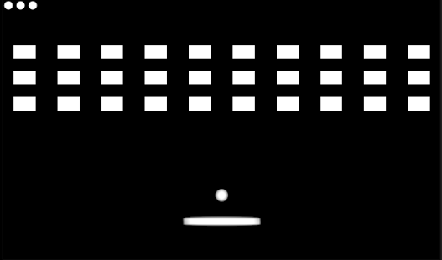

Player 1 Player 2

Source: <https://lh5.ggpht.com/Nb89RFGYgRJ1mk2jztdVzZ0LRq6hs_1_Itvn_rWDDdiizJgC2KvmAfWmxzz7PSQWi64=h310>

# 4. Sound Effects

|  |  |  |
| --- | --- | --- |
| Sound Effect Name | Brief Description | Event which Triggers Playback |
| brick smash | an explosion noise | ball smashes brick |
| ball touches paddle | ball hitting ping pong paddle noise | ball touches the paddle |
| ball touches wall | dull thud noise | ball touches the wall |

Music: Bad Symbol - Cumar & Braedan

# 5. Additional Features (Time Permitting)

If time permits there will be some power-up released from bricks when smashed along with other features. These power-ups and features will be the following:

* Multiple levels
* Leader-board
* Extra lives
* Multi-ball power up
* A wider paddle power up
* Impermeable brick
* Faster paddle movement power up
* Super ball power up (smashes bricks and continues in the same direction, not bouncing until hitting a wall)